Call Sheet Number: 1 of 1
Production Name: Afterglow Music Video
Date: 12th November 2017

CONTACT NUMBERS

Crew Role | Name |  | Number |  | Number
Producer, director, design manager | Dan Chubb | M: | 07956098331 | H: | 01584873376
Producer, director, prop manager | James Gittins | M: | 07983255659 | H: | 01299270457
Producer, director, editing and sound manager | Ben Macvean | M: | 07419344384 | H: | 01299271519
 |  | M: |  | H:
 |  | M: |  | H:
 |  | M: |  | H:
 |  | M: |  | H:

Character | Actor |  | Number |  | Number
1 | Dan Chubb | M: | 07956098331 | H: | 01584873376
2 | James Gittins | M: | 07983255659 | H: | 01299270457
3 | Ben Macvean | M: | 07419344384 | H: | 01299271519
 |  | M: |  | H:
 |  | M: |  | H:
 |  | M: |  | H:
 |  | M: |  | H:
 |  | M: |  | H:
Useful Numbers |  | Email address
Iain Fox (Media teacher) |  | foxi@hlcollege.ac.uk
Ludlow College | M: | 01584872846 | H:
 | M: |  | H:
 | M: |  | H:

Health and Safety
Please read the risk assessment attached.
If you have any concerns, please speak to Council on location
Your first aider on location is Ben Macvean

Ludlow Hospital  Tel:01584872201 | Ludlow Police Station  Tel: 101 (999 for emergencies)

Date:
12TH Nov 2017
 | SCHEDULE | NOTES | LOCATION
0700 | Arrive on location. Set up equipment |  | Titterstone Clee
0800 | Filming | See shot list | Titterstone Clee
0900 | Filming | See shot list | Titterstone Clee
1000 | Filming | See shot list | Titterstone Clee
1100 | Filming | See shot list | Titterstone Clee
1200 | Lunch |  | Clee Hill Village
1300 | Lunch |  | Clee Hill Village
1400 | Filming | See shot list | Titterstone Clee
1500 | Filming | See shot list | Titterstone Clee
1600 | Filming | See shot list | Titterstone Clee
1700 | Filming | See shot list | Titterstone Clee
1800 | Filming | See shot list | Titterstone Clee
1900 | Filming | See shot list | Titterstone Clee
2000 | Pack up and leave |  | Titterstone Clee
Equipment , Costume and Props Required:

Equipment/Props | To be sourced from/responsibility? | Booked?
Smoke Bombs | Amazon | Yes, Ordered on 2nd November
Tripod x2 | Ben | Owned
Slider | Ben | Owned
Tripod | Dan | Owned
Car | Dan | Owned
Camera | Ben | Owned
Camera | Dan | Owned
Telephoto Zoom Lens | Dan | Owned
Lighting | Dan | Owned
Other lenses, misc. items | Ben | Owned

Locations / Maps / Directions
Titterstone Clee Hill

Attach maps of your location and directions to locations for all cast and crew below
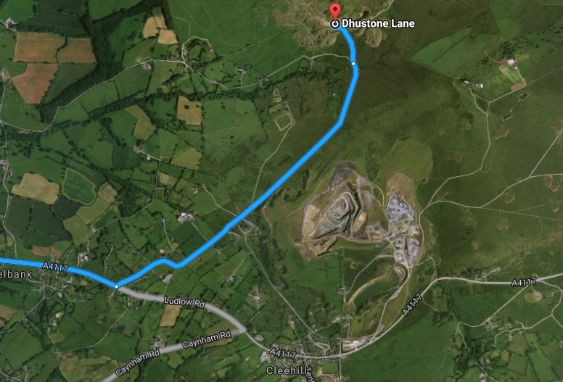
From A4117 east bound. Turn left just after Angelbank.

